SIMATS ENGINEERING
ASSESSMENT TOOL 3

COURSE NAME: Fundamentals of Data Science COURSE CODE: DSA04

COURSE OUTCOME COVERED

CO2: Apply data pre-processing and visualization techniques using Python libraries for effective data handling. (BL4)

QUESTIONS: 05 Total Marks:100

Annexure A

ANALYTICAL PROBLEM SOLVING

Code of Conduct:

I ___A.Sai Rohit (192472144)____ (Name / Reg No) certify that this submission is my original work and that I have adhered to the guidelines specified for this assessment.
I understand that any violation of academic integrity rules will result in disciplinary action.

Signature of the student: A.Sai Rohit

Annexure A

Analytical Problem Solving

1. Online Food Delivery Data Analysis
An online food delivery company wants to analyze order data to improve delivery performance and customer satisfaction. Explain how:
A. Pandas is used to read, clean, and filter order data
B. Data preprocessing is applied to handle missing delivery time, duplicate orders, and incorrect prices
C. Matplotlib or Seaborn is used to visualize delivery delays, top restaurants, and customer ratings

2. Bank Loan Approval Analysis
A bank wants to study customer loan applications and identify patterns related to loan approval and rejection. Explain how:
A. Pandas DataFrame operations are used to select income, loan amount, credit score, and approval status
B. Preprocessing techniques are used to handle missing income values, encode gender/employment type, and normalize loan amount
C. Visualization is used to compare approved and rejected applications based on income, credit score, and loan amount

3. Smart Energy Consumption Monitoring
A smart home system collects daily electricity consumption data from different appliances such as AC, fan, light, and refrigerator. Explain how:
A. Pandas is used to group electricity usage by appliance and date
B. Data preprocessing is used to remove abnormal readings, fill missing values, and calculate total power consumption
C. Line charts and bar charts are used to identify high-energy appliances and daily usage trends

4. Online Learning Platform Performance Analysis
An online learning platform wants to analyze student activity such as login time, video completion, quiz score, and assignment submission. Explain how:
A. Pandas is used to sort, filter, and rank students based on quiz scores and completion percentage
B. Preprocessing is applied to handle missing quiz scores, convert date formats, and create new columns such as performance category
C. Seaborn and Matplotlib are used to visualize student engagement, score distribution, and course completion status

5. Public Transport Passenger Data Analysis
A city transport department wants to analyze bus passenger data to improve route planning and reduce overcrowding. Explain how:
A. Pandas is used to analyze passenger count by route, stop, and time slot
B. Data preprocessing is used to clean invalid route numbers, handle missing passenger counts, and remove duplicate records
C. Visualization techniques are used to show peak travel hours, busiest routes, and passenger flow patterns

RUBRICS FOR CALCULATION

Criteria | Weightage | Level 4 – Exemplary (5 Marks) | Level 3 – Proficient (4 Marks) | Level 2 – Developing (2–3 Marks) | Level 1 – Beginning (0–1 Mark)
Conceptual Understanding | 30 | Demonstrates clear and complete understanding of the concept | Good understanding with minor gaps | Basic understanding with some misconceptions | Poor or incorrect understanding
Accuracy of Answer | 25 | Completely correct answer with no errors | Mostly correct with minor errors | Partially correct with noticeable errors | Incorrect or irrelevant answer
Application of Knowledge | 20 | Correctly applies concepts to solve the question/problem | Applies concepts with minor mistakes | Limited or partially correct application | No or incorrect application
Completeness of Response | 15 | Covers all required parts of the question | Covers most parts with minor omissions | Covers only some parts | Incomplete or missing response
Clarity & Presentation | 10 | Clear, concise, and well-organized answer | Understandable with minor issues | Somewhat unclear or poorly structured | Difficult to understand

1. Online Food Delivery Data Analysis

A. Using Pandas to Read, Clean, and Filter Order Data
Pandas is a powerful Python library used for data manipulation and analysis. In this project, it is used to create a DataFrame containing food delivery details such as Order ID, Restaurant Name, Delivery Time, Price, and Customer Rating. Pandas makes it easy to organize and process the data. The dataset is displayed to understand its structure, and different DataFrame operations are performed. The fillna() function replaces missing delivery times with the average value, drop_duplicates() removes duplicate order records, and filtering is used to remove incorrect prices and display high-rated customer orders. Functions like value_counts() and groupby() are used to calculate restaurant-wise order counts and average delivery time.
Application:
- Organize food delivery data.
- Filter delayed or highly rated orders.
- Count restaurant-wise orders.
- Calculate average delivery time.

B. Data Preprocessing
Data preprocessing is an important step to improve the quality of the dataset before analysis.
- Missing delivery times are replaced with the average delivery time.
- Duplicate order records are removed to avoid repeated information.
- Incorrect prices (negative values) are removed from the dataset.
- Clean data ensures better accuracy and reliable analysis.
Benefits:
- Improves data quality.
- Removes errors and inconsistencies.
- Provides accurate business insights.

C. Visualization using Plotly Express
Plotly Express is used to create interactive visualizations.
- Bar Chart: Displays the number of orders received by each restaurant.
- Bar Chart: Shows the average delivery time of each restaurant.
- Histogram: Displays the distribution of customer ratings.
These visualizations help identify the most popular restaurants, compare delivery performance, and analyze customer satisfaction.

Code:

import pandas as pd
import plotly.express as px

order_data = {
"Order_ID": [101, 102, 103, 104, 105, 106],
"Restaurant": ["KFC", "Dominos", "KFC", "Pizza Hut", "Dominos", "KFC"],
"Delivery_Time": [30, 45, None, 25, 60, 45],
"Price": [350, 450, 250, -200, 500, 450],
"Customer_Rating": [5, 4, 5, 3, 2, 4]
}

df = pd.DataFrame(order_data)

print("Original Data")
print(df)

df["Delivery_Time"] = df["Delivery_Time"].fillna(df["Delivery_Time"].mean())
df = df.drop_duplicates()
df = df[df["Price"] > 0]

print("\nCleaned Data")
print(df)

high_rating = df[df["Customer_Rating"] >= 4]

print("\nOrders with Rating >= 4")
print(high_rating)

top_restaurants = df["Restaurant"].value_counts()

print("\nTop Restaurants")
print(top_restaurants)

delay = df.groupby("Restaurant")["Delivery_Time"].mean().reset_index()

print("\nAverage Delivery Time")
print(delay)

fig1 = px.bar(
x=top_restaurants.index,
y=top_restaurants.values,
labels={"x": "Restaurant", "y": "Orders"},
title="Top Restaurants by Orders"
)

fig2 = px.bar(
delay,
x="Restaurant",
y="Delivery_Time",
title="Average Delivery Time"
)

fig3 = px.histogram(
df,
x="Customer_Rating",
title="Customer Ratings Distribution"
)

fig1.show()
fig2.show()
fig3.show()

Output:

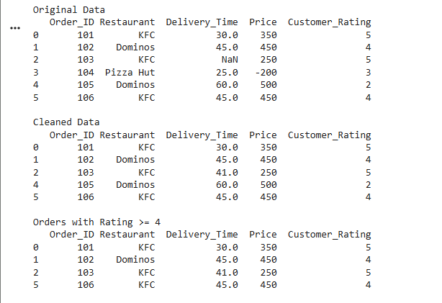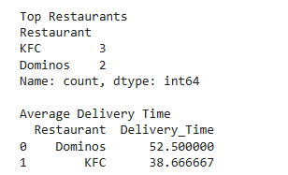

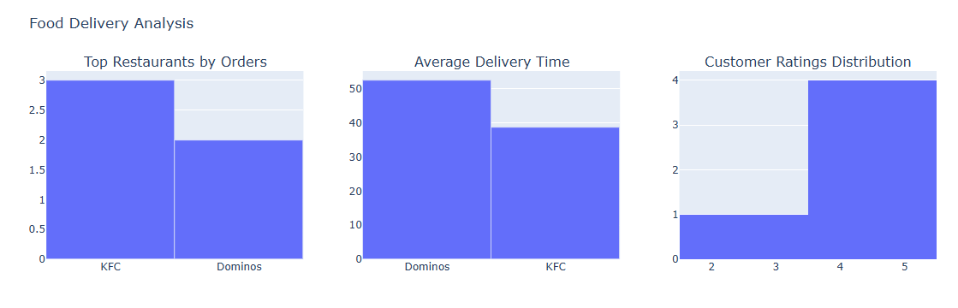

2. Bank Loan Approval Analysis

A. Using Pandas DataFrame Operations
Pandas is used to store customer loan information in a DataFrame. It organizes data such as Income, Loan Amount, Credit Score, Gender, Employment Type, and Approval Status. DataFrame operations help select required columns, sort customer records, and compare approved and rejected applications. These operations make loan data easier to analyze.
Application:
- Select important loan details.
- Compare approved and rejected customers.
- Analyze customer income and loan amount.
- Organize data for further processing.

B. Data Preprocessing
Scikit-learn preprocessing techniques prepare the dataset for analysis.
- Missing income values are replaced with the average income.
- Gender and Employment Type are converted into numerical values using LabelEncoder.
- Loan Amount is normalized using MinMaxScaler so that all values are in the same range.
- These preprocessing techniques improve data consistency and accuracy.
Benefits:
- Handles missing values.
- Converts categorical data into numerical form.
- Makes data suitable for analysis and machine learning.

C. Visualization
Matplotlib and Seaborn are used to create graphs.
- Count Plot: Compares approved and rejected loan applications.
- Scatter Plot: Shows the relationship between Income and Loan Amount.
- Histogram: Displays the distribution of Credit Scores.
These charts help identify patterns in customer loan approval.
Code:

import pandas as pd
import matplotlib.pyplot as plt
import seaborn as sns
from sklearn.preprocessing import LabelEncoder, MinMaxScaler

# Create sample bank loan dataset
data = {
"CustomerID": [101,102,103,104,105,106,107,108],
"Income": [50000,60000,None,45000,70000,55000,65000,48000],
"LoanAmount": [200000,250000,180000,150000,300000,220000,280000,160000],
"CreditScore": [750,680,720,600,800,690,770,640],
"Gender": ["Male","Female","Male","Female","Male","Female","Male","Female"],
"Employment": ["Salaried","Business","Salaried","Business","Salaried","Business","Salaried","Business"],
"ApprovalStatus": ["Approved","Rejected","Approved","Rejected","Approved","Approved","Approved","Rejected"]
}

# Create DataFrame
df = pd.DataFrame(data)

print("Original Dataset")
print(df)

# -----------------------------
# Data Preprocessing
# -----------------------------

# Fill missing income with mean
df["Income"] = df["Income"].fillna(df["Income"].mean())

# Encode Gender
le = LabelEncoder()
df["Gender"] = le.fit_transform(df["Gender"])

# Encode Employment
df["Employment"] = le.fit_transform(df["Employment"])

# Normalize Loan Amount
scaler = MinMaxScaler()
df["LoanAmount"] = scaler.fit_transform(df[["LoanAmount"]])

print("\nCleaned Dataset")
print(df)

# -----------------------------
# Select Required Columns
# -----------------------------
selected = df[["Income","LoanAmount","CreditScore","ApprovalStatus"]]

print("\nSelected Columns")
print(selected)

# -----------------------------
# Visualization 1
# Approved vs Rejected Applications
# -----------------------------
plt.figure(figsize=(6,4))
sns.countplot(x="ApprovalStatus", data=df)
plt.title("Loan Approval Status")
plt.xlabel("Approval Status")
plt.ylabel("Number of Applications")
plt.show()

# -----------------------------
# Visualization 2
# Income vs Loan Amount
# -----------------------------
plt.figure(figsize=(6,4))
sns.scatterplot(x="Income", y="LoanAmount", hue="ApprovalStatus", data=df)
plt.title("Income vs Loan Amount")
plt.show()

# -----------------------------
# Visualization 3
# Credit Score Distribution
# -----------------------------
plt.figure(figsize=(6,4))
sns.histplot(df["CreditScore"], bins=5, kde=True)
plt.title("Credit Score Distribution")
plt.xlabel("Credit Score")
plt.ylabel("Frequency")
plt.show()

Output:

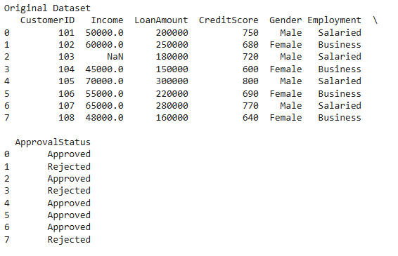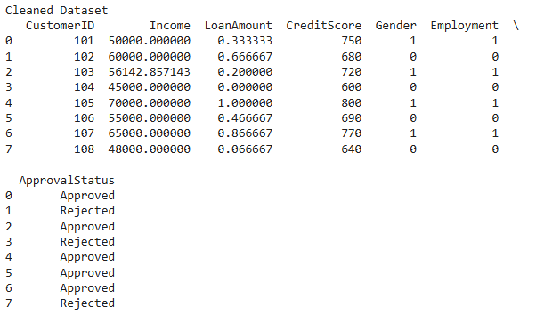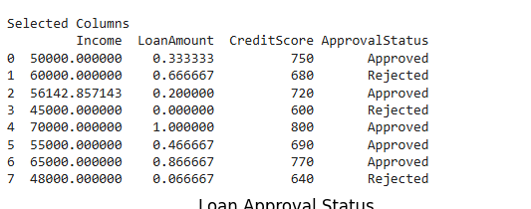
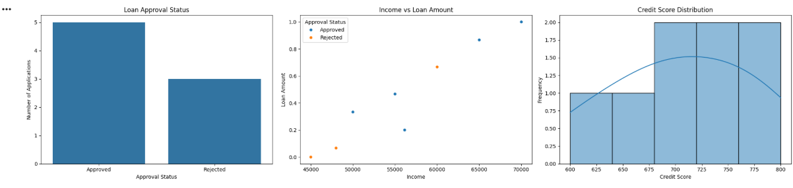

3. Smart Energy Consumption Monitoring

A. Using Pandas
Pandas is used to organize electricity consumption data in a DataFrame. The dataset contains Date, Appliance Name, and Power Consumption. Using groupby(), electricity usage is grouped by appliance and date. The total power consumption is calculated to identify energy usage patterns.
Application:
- Group electricity usage by appliance.
- Group daily energy consumption.
- Calculate total power usage.
- Compare appliance-wise electricity consumption.

B. Data Preprocessing
Before analysis, the dataset is cleaned.
- Missing power values are replaced with the average value.
- Duplicate records are removed.
- Abnormal power readings are removed.
- Total electricity consumption is calculated.
These preprocessing steps improve the reliability of the energy data.
Benefits:
- Improves data quality.
- Removes incorrect values.
- Produces accurate energy reports.

C. Visualization using Plotly Express
Plotly Express creates interactive visualizations.
- Bar Chart: Displays electricity consumption for each appliance.
- Line Chart: Shows daily electricity usage trends.
These graphs help identify high-energy appliances and monitor daily electricity consumption.

Code:

import pandas as pd
import plotly.express as px

# Create sample dataset
data = {
"Date": ["2026-07-01","2026-07-01","2026-07-01","2026-07-01",
"2026-07-02","2026-07-02","2026-07-02","2026-07-02"],
"Appliance": ["AC","Fan","Light","Refrigerator",
"AC","Fan","Light","Refrigerator"],
"Power": [5.2,1.1,None,2.3,5.5,1.0,0.8,20]
}

df = pd.DataFrame(data)

print("Original Dataset")
print(df)

# Data Preprocessing
df["Power"] = df["Power"].fillna(df["Power"].mean())
df = df.drop_duplicates()
df = df[df["Power"] <= 10]

# Total Power Consumption
total_power = df["Power"].sum()
print("\nTotal Power Consumption:", total_power)

# Group by Appliance
appliance_usage = df.groupby("Appliance")["Power"].sum().reset_index()
print("\nPower Consumption by Appliance")
print(appliance_usage)

# Group by Date
daily_usage = df.groupby("Date")["Power"].sum().reset_index()
print("\nDaily Power Consumption")
print(daily_usage)

# Bar Chart
fig1 = px.bar(
appliance_usage,
x="Appliance",
y="Power",
title="Power Consumption by Appliance"
)
fig1.show()

# Line Chart
fig2 = px.line(
daily_usage,
x="Date",
y="Power",
markers=True,
title="Daily Power Consumption Trend"
)
fig2.show()

Output:

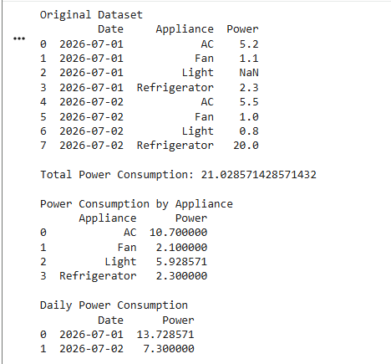

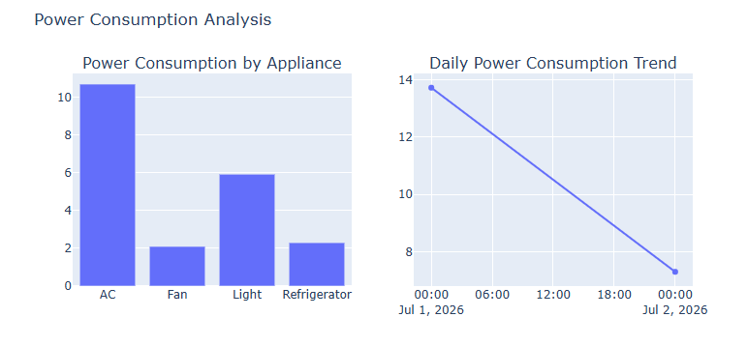

4. Online Learning Platform Performance Analysis

A. Using Pandas
Pandas is used to manage student activity data such as Student Name, Login Date, Quiz Score, Course Completion, and Assignment Status. It sorts students by quiz score, ranks them according to performance, and filters records based on completion percentage. This helps evaluate student progress.
Application:
- Rank students.
- Sort quiz scores.
- Analyze course completion.
- Evaluate student performance.

B. Data Preprocessing
Data preprocessing improves the dataset before analysis.
- Missing quiz scores are replaced with the average score.
- Login dates are converted into datetime format.
- A new column called Performance Category is created based on quiz scores.
These steps improve the accuracy of student performance analysis.
Benefits:
- Better student classification.
- Accurate performance evaluation.
- Easy reporting.

C. Visualization
Matplotlib and Seaborn are used to create visual reports.
- Histogram: Displays quiz score distribution.
- Count Plot: Shows the number of students in each performance category.
- Bar Chart: Displays course completion percentages.
These charts help understand student engagement and academic performance.

Code:

import pandas as pd
import matplotlib.pyplot as plt
import seaborn as sns

# Create sample student dataset
data = {
"Student": ["Sai", "Rahul", "Anu", "Priya", "Kiran", "Ravi", "Meena", "Arjun"],
"LoginDate": ["2026-07-01", "2026-07-02", "2026-07-01", "2026-07-03",
"2026-07-02", "2026-07-01", "2026-07-03", "2026-07-02"],
"QuizScore": [85, None, 92, 68, 75, 55, 98, 80],
"Completion": [90, 75, 100, 60, 85, 50, 100, 95],
"Assignment": ["Yes", "No", "Yes", "Yes", "No", "Yes", "Yes", "No"]
}

# Create DataFrame
df = pd.DataFrame(data)

print("Original Dataset")
print(df)

# -----------------------------
# Data Preprocessing
# -----------------------------

# Fill missing quiz scores
df["QuizScore"] = df["QuizScore"].fillna(df["QuizScore"].mean())

# Convert LoginDate to datetime format
df["LoginDate"] = pd.to_datetime(df["LoginDate"])

# Create Performance Category
def performance(score):
if score >= 90:
return "Excellent"
elif score >= 75:
return "Good"
elif score >= 50:
return "Average"
else:
return "Needs Improvement"

df["Performance"] = df["QuizScore"].apply(performance)

print("\nCleaned Dataset")
print(df)

# -----------------------------
# Sort Students by Quiz Score
# -----------------------------
sorted_df = df.sort_values(by="QuizScore", ascending=False)

print("\nStudents Sorted by Quiz Score")
print(sorted_df)

# -----------------------------
# Rank Students
# -----------------------------
df["Rank"] = df["QuizScore"].rank(ascending=False)

print("\nStudent Rankings")
print(df[["Student", "QuizScore", "Rank"]])

# -----------------------------
# Visualization 1
# Quiz Score Distribution
# -----------------------------
plt.figure(figsize=(7,5))
sns.histplot(df["QuizScore"], bins=5, kde=True)
plt.title("Quiz Score Distribution")
plt.xlabel("Quiz Score")
plt.ylabel("Number of Students")
plt.show()

# -----------------------------
# Visualization 2
# Performance Categories
# -----------------------------
plt.figure(figsize=(7,5))
sns.countplot(x="Performance", data=df)
plt.title("Student Performance Categories")
plt.xlabel("Performance")
plt.ylabel("Number of Students")
plt.show()

# -----------------------------
# Visualization 3
# Course Completion Percentage
# -----------------------------
plt.figure(figsize=(7,5))
sns.barplot(x="Student", y="Completion", data=df)
plt.title("Course Completion Percentage")
plt.xlabel("Student")
plt.ylabel("Completion (%)")
plt.show()

Output:

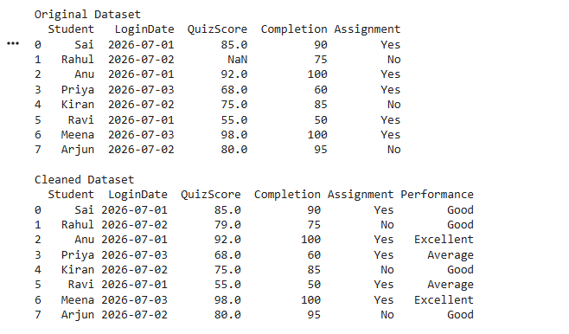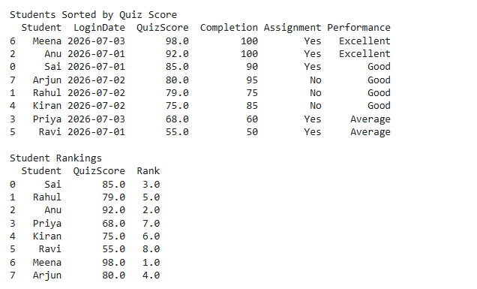
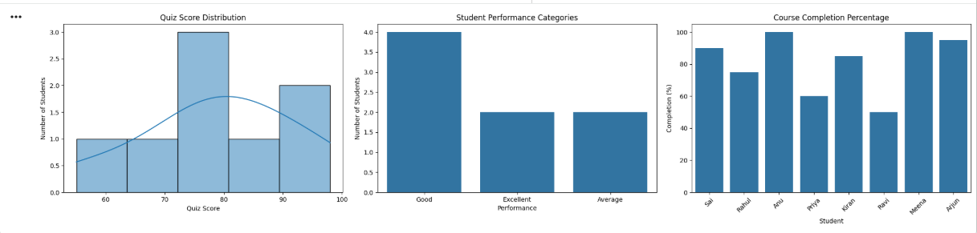

5. Public Transport Passenger Data Analysis

A. Using Pandas
Pandas is used to organize passenger information in a DataFrame. The dataset contains Route Number, Bus Stop, Time Slot, and Passenger Count. Using groupby(), passenger counts are analyzed by route, stop, and time slot. This helps identify the busiest routes and travel periods.
Application:
- Analyze passenger count by route.
- Analyze passenger count by stop.
- Identify peak travel hours.
- Support route planning.

B. Data Preprocessing
Before analysis, the passenger data is cleaned.
- Missing passenger counts are replaced with the average value.
- Duplicate records are removed.
- Invalid route numbers are deleted.
- Clean data improves the reliability of passenger analysis.
Benefits:
- Removes incorrect records.
- Improves analysis accuracy.
- Supports better transport management.

C. Visualization using Altair
Altair is used to create simple and interactive visualizations.
- Bar Chart: Displays passenger counts for each route to identify the busiest routes.
- Line Chart: Shows passenger counts across different time slots to identify peak travel hours.
These visualizations help understand passenger flow and improve route planning.

Code:

import pandas as pd
import altair as alt

# Create sample passenger dataset
data = {
"Route": ["101","102","101","103","102","101","Invalid","103"],
"Stop": ["A","B","C","A","B","C","D","A"],
"TimeSlot": ["8 AM","8 AM","9 AM","9 AM","10 AM","10 AM","8 AM","10 AM"],
"PassengerCount": [45,60,None,35,55,70,40,65]
}

# Create DataFrame
df = pd.DataFrame(data)

print("Original Dataset")
print(df)

# Data Preprocessing
df["PassengerCount"] = df["PassengerCount"].fillna(df["PassengerCount"].mean())
df = df.drop_duplicates()
df = df[df["Route"] != "Invalid"]

print("\nCleaned Dataset")
print(df)

# Passenger Count by Route
route_data = df.groupby("Route")["PassengerCount"].sum().reset_index()
print("\nPassenger Count by Route")
print(route_data)

# Passenger Count by Stop
stop_data = df.groupby("Stop")["PassengerCount"].sum().reset_index()
print("\nPassenger Count by Stop")
print(stop_data)

# Passenger Count by Time Slot
time_data = df.groupby("TimeSlot")["PassengerCount"].sum().reset_index()
print("\nPassenger Count by Time Slot")
print(time_data)

# -----------------------------
# Bar Chart - Busiest Routes
# -----------------------------
bar_chart = alt.Chart(route_data).mark_bar().encode(
x='Route:N',
y='PassengerCount:Q',
tooltip=['Route', 'PassengerCount']
).properties(
title='Passenger Count by Route'
)

bar_chart.display()

# -----------------------------
# Line Chart - Peak Travel Hours
# -----------------------------
line_chart = alt.Chart(time_data).mark_line(point=True).encode(
x='TimeSlot:N',
y='PassengerCount:Q',
tooltip=['TimeSlot', 'PassengerCount']
).properties(
title='Passenger Count by Time Slot'
)

line_chart.display()

Output:

